**Part III. Graphing Marginal Damage Curves**

The tables are a helpful way to organize the data and do some basic calculations, but when presenting the data, graphs are a better way to convey a lot of information in one figure. In this section we will make graphs of the expected marginal damage curves you just calculated for each SLR scenario.

**IN EXCEL**

**At the bottom of the Excel window click on the ‘MD graphs’ tab.** Here you will see 3 tables, each showing the different SLR scenarios and expected flood damages for years, 2050, 2100, and 2150. The tables have automatically populated with the expected MD values you calculated on the previous spreadsheet.

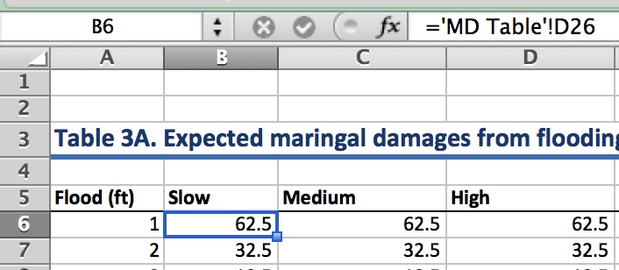

Note: If you click on a cell, you can see the reference cell it’s drawing the data from in the formula bar (*fx*) at the top, where ‘MD Table’ is the sheet name you were previously working in and D26 is the cell on that sheet the data is copied from.

I have already made a graph of Table 3A, now you will make a graph of Table 3B.

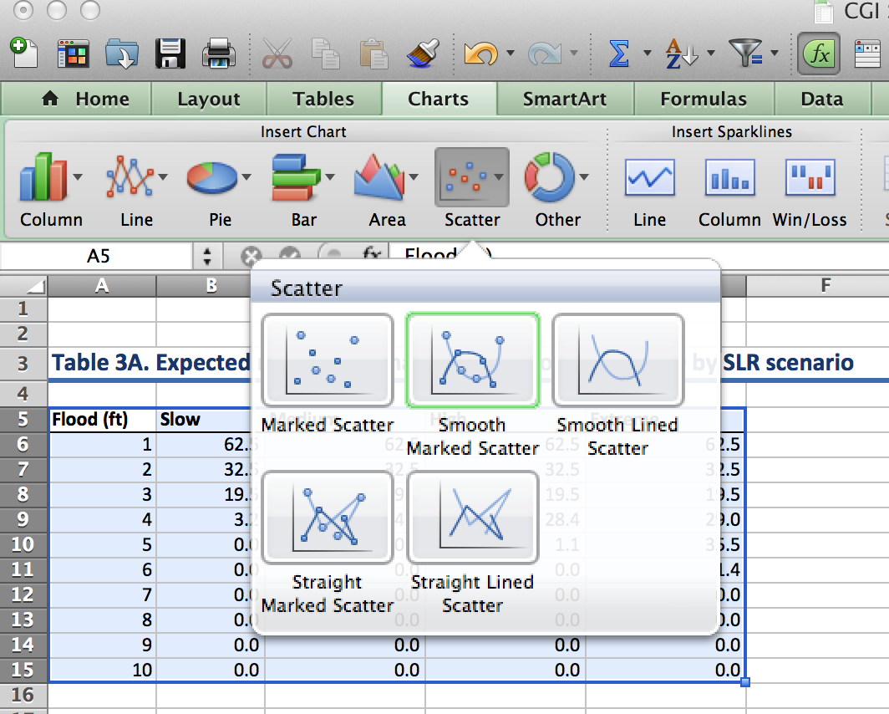

**To make a graph in Excel:**

**1. Use the cursor and drag to highlight the contents of Table 3B as pictured.**

**2. Click Insert > Chart > Scatter > Smooth Marked Scatter**

**Then a graph should appear in the spreadsheet!**

You can click on the graph to move it around on your spreadsheet.

Note: The x-axis will be based on the left-hand column units (feet) and the y-axis will be the units from the columns to the right (millions of dollars). The legend is based on the column headings.

**Next, repeat the same thing to make a graph of Table 3C.**

Once your graphs are created, you will want to add titles to the graph and the axes. If someone was to look at your graph out of context, they should be able to understand exactly what data is being displayed.

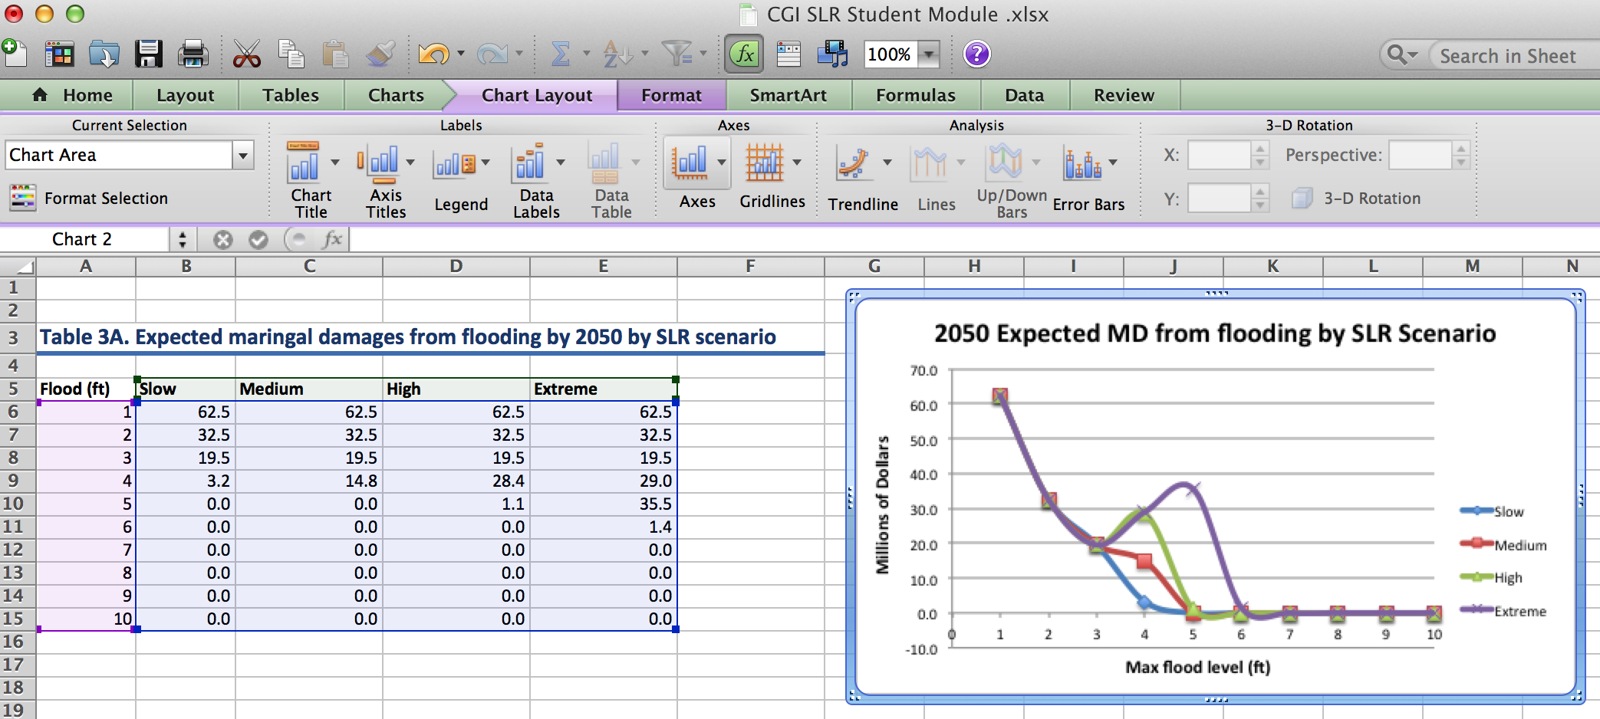

**To add titles, click anywhere on the graph and then you should see a ‘Chart Layout’ tab appear. Click on that and from there you should see options for adding a Chart Title and Axis Titles.**

**Pause for Analysis**

|  |
| --- |
| 2. Looking at the graphs, what is your hypothesis for why the highest marginal damages are from the first couple feet of flooding? |
|  |
| 3. Comparing the three graphs, what is a claim you can make about damages from sea level rise? Support your claim with evidence from the graphs. |
|  |

**Pause for Reflection**

You now have three graphs to analyze that show expected marginal damages from flooding over different time periods. While they provide useful information, as a policy-maker in Tacoma, what challenges and limitations do you foresee in using these graphs for decision making?

|  |
| --- |
| **Briefly Explain:** |

**Part IV. Making decisions given uncertainty**

Along with risk and uncertainty about the likelihood of maximum flood levels, there is also inherent uncertainty about which sea level rise scenario is most likely to play out. One way to account for this uncertainty in decision-making is by using the same expected value approach we used for calculating the expected marginal damages of flooding.

There are four SLR scenarios that will occur with some probability, *pj*, where *j* represents the SLR scenario: slow, medium, high, or extreme. For each flood level, *i*, we can estimate the expected marginal damage given the probability of each SLR scenario.

$$Expected \left({MD}_{i}\right)= p_{s}*E\left({MD}_{si}\right)+p_{m}*E\left({MD}_{mi}\right)+p_{h}*E\left({MD}_{hi}\right)+p_{e}*E\left({MD}_{ei}\right)$$

$$for i=1, 2,... ,10$$

|  |  |  |
| --- | --- | --- |
| Determining the probability of each SLR scenario occurring given Polar ice melt is a current area of research by climate scientists. To prepare for the next Excel activity, think about the different scenarios and assign probabilities to each one below. It’s okay if this is arbitrary. | | |
| **Scenario** | **Probability** | Remember that the scenarios are mutually exclusive, so the probabilities must sum to one. |
| Slow (0.2 meter rise) |  |
| Medium (1.0 meter rise) |  |
| High (2.0 meter rise) |  |
| Extreme (3 meter rise) |  |

**BACK TO EXCEL**

We can use the probabilities you just assigned for the SLR scenarios to graph one expected marginal damage curve that incorporates the likelihood of each scenario occurring.

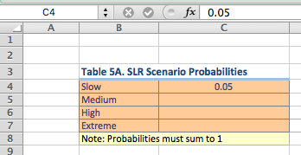**Click on the ‘MD MC Graph’ tab at the bottom of your Excel worksheet.**

At the top you will see a Table 5A for SLR scenarios probabilities.

**Type in your probabilities from above for each SLR scenario.**

Notice, after you fill in the probabilities, Table 5B automatically populates using the marginal expected damage formula for the year 2100. To the right you can see the graph of the expected marginal damage curve based on the probabilities you chose.

The likelihood of different SLR scenarios occurring will directly impact the expected marginal damages associated with SLR and flooding. To better understand this idea, we can adjust the probabilities of different scenarios occurring and compare the marginal damage curves.

**In Table 6A 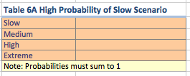choose probabilities for the SLR scenarios such that the “Slow” scenario has the highest probability of occurring and the extreme scenario the lowest.**

**In Table 6B choose probabilities for the SLR scenarios so that the “Extreme” scenario has the highest probability of occurring.**

As you enter the probabilities into Tables 6A and 6B, you will notice that Table 6C populates with the expected marginal damages, and the graph on the right displays the expected MD curves for each set of probabilities.

**Copy and paste the graph of Table 6C below.**

**Figure 6C: Expected MD from Flooding by 2100**

(Paste graph here)

**Pause for Analysis**

|  |
| --- |
| 4. Looking at the graph above and considering what you now know about calculating expected values, how do the probabilities affect the expected MD curves? |
|  |

The final step in our analysis is to consider how much it would cost to prevent these damages. One of the options to consider is building a sea wall along the shoreline that would prevent the water from reaching the homes given a flooding event.

In a report on cost estimates of coastal protection, the researchers estimate that the cost of building a sea wall is $762 per square foot (Hudson et al. 2015).

If Ruston Way is considered the highest priority shoreline, and it is 4.2 miles long, we can estimate that the cost of a 1-foot sea wall covering the entire distance would be $16.9 millions dollars. To simplify the analysis, we will assume that the cost of building the sea wall one foot taller is **constant** at $762 per square foot.

**Use this information to fill in the ‘Marginal Cost’ column in Table 7.**

**Make a graph that displays the Marginal Cost and Expected Marginal Damages given different flood levels. Make sure to give the graph a title and to label the x- and y-axes.**

**Copy and Paste your graph from Excel into the space below:**

**Pause for Analysis**

|  |
| --- |
| 5. Based on your graph above, what recommendation would you make to an urban planner regarding SLR adaptation in Tacoma? |
|  |
| 6. What is one assumption that is underlying the graph of Table 7 and if you were to change this assumption, how do you think the results change? |
|  |
| 7. What are some of the limitations of using these graphs for decision-making? |
|  |

**References**

DeConto, R. and Pollard, D. 2016. Contribution of Antarctica to past and future sea-level rise. *Nature*. 531, 591–597. doi:10.1038/nature17145

Hauer, M. E., J. M. Evans, and D R. Mishra (2016). Millions projected to be at risk from sea-level rise in the continental United States. Nature Climate Change.

Murphy, J. October 14, 2015. The Nation. Retrieved from: <https://www.thenation.com/article/3-years-after-hurricane-sandy-is-new-york-prepared-for-the-next-great-storm/>

Hudson, T., Keating, K., and Pettit, A. 2015.Cost estimation for coastal protection – summary of evidence. Environmental Agency. Report –SC080039/R7

National Geographic Magazine. Antarctica is Melting at a Dangerous Pace – Here’s Why. June 22, 2017. Retrieved from <http://video.nationalgeographic.com/video/magazine/170622-ngm-antarctica-melting-sea-levels-climate-change>

NOAA 2017: Sweet, W. V., Kopp, R. E., Weaver, C. P., Obeysekara, J., Horton, R. M., Thieler, E. R., and Zervas, C. (2017). Global and Regional Sea Level Rise Scenarios for the United States. NOAA Technical Report NOS CO-OPS 083.

Parris, A., P. Bromirski, V. Burkett, D. Cayan, M. Culver, J. Hall, R. Horton, K. Knuuti, R. Moss, J. Obeysekera, A. Sallenger, and J. Weiss (2012). Global Sea Level Rise Scenarios for the US National Climate Assessment. NOAA Tech Memo OAR CPO-1. 37 pp.

Sneed, A. 2017. How Is Worldwide Sea Level Rise Driven by Melting Arctic Ice? *Scientific American*. June 5, 2017. Retrieved from: https://www.scientificamerican.com/article/how-is-worldwide-sea-level-rise-driven-by-melting-arctic-ice/